|  |  |  |
| --- | --- | --- |
| Car Library | May 4  2018 | |
| Rich Internet Applications  Msc ic Software Engineering  Niall Collins | | A00144538 |

**Database Running on MYSQL Workbench**

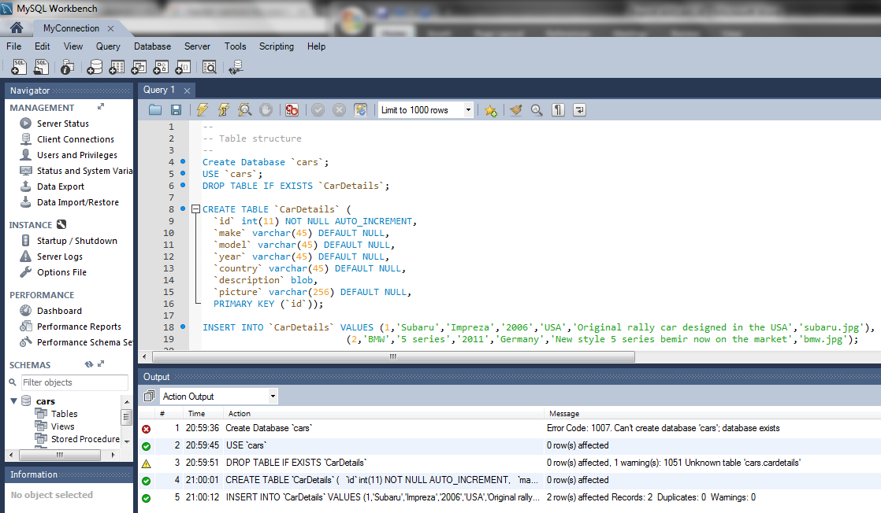

**Quarry on Database**

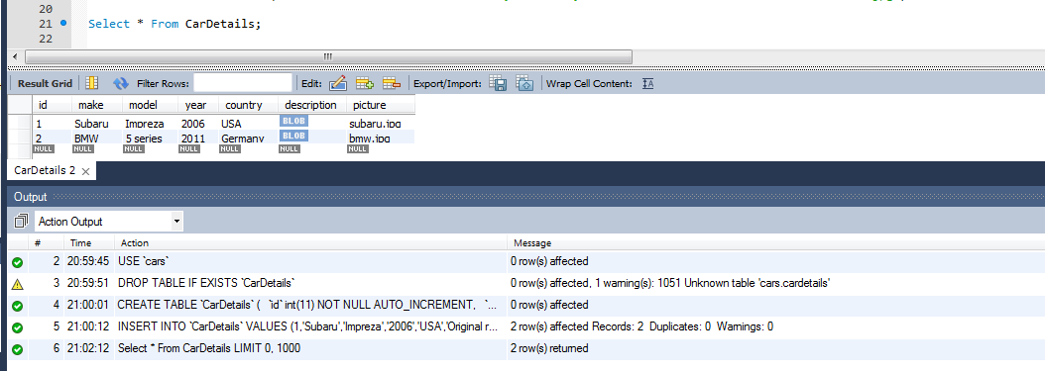

**Webpage screens running in Eclipse**

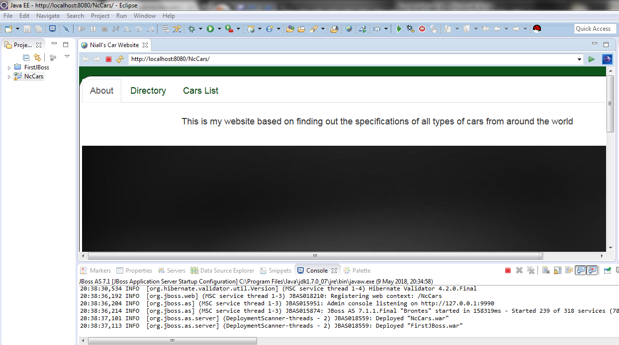

**Webpage screens running on Chrome browser**

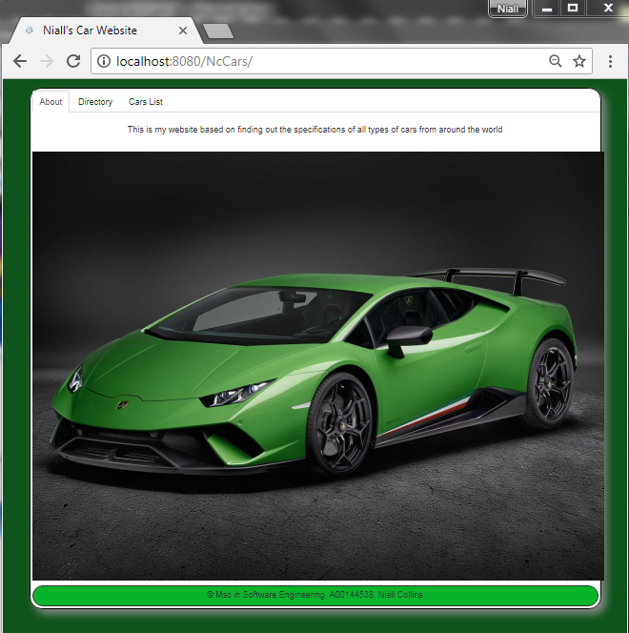

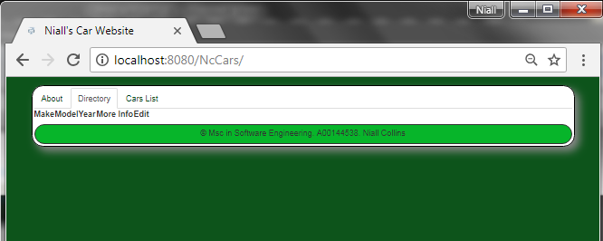

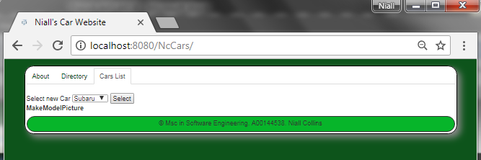

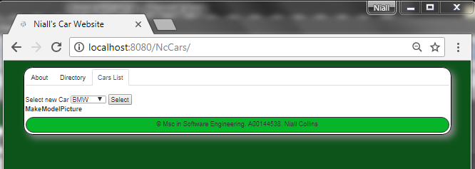

**User stories (based on Test Driven Development approach)**

|  |  |  |  |  |
| --- | --- | --- | --- | --- |
| **Number** | **Priority** | | **Name** | |
| 1 | 1 | | View all Cars (GET All) | |
|  | **As a/an...** | **I want to...** | | **So that...** |
| API Consumer | Retrieve data in JSON format for all Cars I have in the System | | I can use the data in my client application |
| **Acceptance criteria** | | | |
| **Scenario 1 – Unsuccessful request** | | | |
| **Given** | **When** | | **Then** |
| * Application Server and Database Server are running. | * A GET request is submitted to http://localhost:8080/NcCars | | * All Cars are received in JSON format |

|  |  |  |  |  |
| --- | --- | --- | --- | --- |
| **Number** | **Priority** | | **Name** | |
| 2 | 2 | | View one Car (GET one based on ID) | |
|  | **As a/an...** | **I want to...** | | **So that...** |
| API Consumer | Retrieve data in JSON format for one single Car I have in the System | | I can use the data in my client application |
| **Acceptance criteria** | | | |
| **Scenario 2 – Unsuccessful request** | | | |
| **Given** | **When** | | **Then** |
| * Application Server and Database Server are running. | * A GET request is submitted to http://localhost:8080/NcCars/1 | | * Car with the ID 1 IS received in JSON format |

|  |  |  |  |  |
| --- | --- | --- | --- | --- |
| **Number** | **Priority** | | **Name** | |
| 3 | 3 | | Update Car details (PUT) | |
|  | **As a/an...** | **I want to...** | | **So that...** |
| API Consumer | Update or change data in JSON format for all Cars in the System | | I can use the data in my client application |
| **Acceptance criteria** | | | |
| **Scenario 3 – Unsuccessful request** | | | |
| **Given** | **When** | | **Then** |
| * Application Server and Database Server are running. | * A PUT request is submitted to http://localhost:8080/NcCars/1 | | * Car with ID 10 is updated in JSON format |

|  |  |  |  |  |
| --- | --- | --- | --- | --- |
| **Number** | **Priority** | | **Name** | |
| 4 | 4 | | Add a new Car (POST) | |
|  | **As a/an...** | **I want to...** | | **So that...** |
| API Consumer | Add data in JSON format for a new Car to be put in the System | | I can use the data in my client application |
| **Acceptance criteria** | | | |
| **Scenario 4 – Unsuccessful request** | | | |
| **Given** | **When** | | **Then** |
| * Application Server and Database Server are running. | * A POST request is submitted to http://localhost:8080/NcCars | | * Car with the next available ID is created in JSON format |

|  |  |  |  |  |
| --- | --- | --- | --- | --- |
| **Number** | **Priority** | | **Name** | |
| 5 | 5 | | Delete Car details (DELETE) | |
|  | **As a/an...** | **I want to...** | | **So that...** |
| API Consumer | Delete data for Cars in the System | | I can use the data in my client application |
| **Acceptance criteria** | | | |
| **Scenario 5 – Unsuccessful request** | | | |
| **Given** | **When** | | **Then** |
| * Application Server and Database Server are running. | * A DELETE request is submitted to http://localhost:8080/NcCars/1 | | * Car with ID 1 is deleted |

**Manual Testing**

